**MCSE 1 Lecture 3**

**IP Addressing**

**IP addresses**

Computers communicate with each other by sending packets to the IP address assigned to the computers. An analogy would be our postal system. Every house has its own unique address to which we send mail. Every computer requires a unique IP address.

The IP address is 32 bits long. It is subdivided into 4 blocks of 8 bits. Each block of 8 bits is represented by its equivalent decimal number. We call the IP address a “dotted-decimal” number.

Example of an IP address:

**192.168.1.1**

The binary equivalent is:

**1100 0000. 1010 1000. 0000 0001. 0000 0001**

**Working with the Binary Number System**

To understand how IP addresses are used by the computer, you need to know something about the binary numbering system.

If you take the decimal number 7492, it can be expressed as powers of 10 as shown below:

**7492 = (7 x 103) + (4 x 102) + (9 x 101) + (2x100)**

**7492 = (7 x 1000) + (4 x 100) + (9 x 10) + (2x1)**

**7492 = (7000) + (400) + (90) + (2)**

**7492**

Binary numbers can be expressed as powers of 2 just as decimal numbers are expressed as powers of 10. A byte is the most common unit for expressing binary numbers. A byte is 8 bits. A bit is either a “1” or a “0”. Each bit has a weighted value based on a power of 2 as shown below.

**27 26 25  24  23 22 21 20**

Weighted values = **128 64 32 16 8 4 2 1**

We can use the weighted values to help us convert a binary number into a decimal number.

**1011 0110 = (1 x 128)+(0 x 64)+(1 x 32)+(1 x 16)+(0 x 8)+(1 x 4)+(1 x 2)+(0 x 1)**

**1011 0110 = (128)+(0)+(32)+(16)+(0)+(4)+(2)+(0) = 182**

You can convert a decimal number into a binary number by subtracting the weighted positions starting at the left. The binary equivalent of 213 is:

**213 – 128 = 85 binary number is 1**

**85 - 64 = 21 binary number is 11**

**21 - 32 = doesn’t go binary number is 110**

**21 - 16 = 5 binary number is 1101**

**5 - 8 = doesn’t go binary number is 1101 0**

**5 - 4 = 1 binary number is 1101 01**

**1 - 2 = doesn’t go binary number is 1101 010**

**1 - 1 = 0 binary number is 1101 0101**

Therefore: **213** in decimal = **1101 0101** in binary.

**IP Classes**

IANA (Internet Assigned Number Authority) is in charge of assigning IP networks to ISPs who in turn supply their clients with an IP address.

The IP address space is divided into classes called A, B, C, D, and E. Class A, B, and C are assigned to users for regular communications purposes. Class D is used for multicasting and class E is used for experimentation and research.

Table 1 shows the differences between class A, B, and C.

|  |  |  |  |
| --- | --- | --- | --- |
| **Class** | **Range of 1st Octet** | **N = Network**  **H = Host** | **Number of hosts per network** |
| **A** | **1 - 127** | **N.H.H.H** | **2n – 2 = 16,777,214** |
| **B** | **128 - 191** | **N.N.H.H** | **2n – 2 = 65,534** |
| **C** | **192 - 223** | **N.N.N.H** | **2n – 2 = 254** |

Table 1 Class A, B, and C licenses

**You can tell which class of license an IP address belongs to by checking the first octet against the second column in table 1.**

For instance, the IP address 157.99.0.6 is a class B license because the first octet, “157”, falls between the 128 and 191 range.

**Note**: there is no license issuable for 127. This is reserved as a “loop-back” address for protocol stack testing.

The third column in table 1 shows how many octets are used for the network portion of the address for each class of license. The “N” means this octet is used for the network portion. The “H” means this octet is used for the host portion. Class A uses the first octet or 8 bits for the network portion. The other 24 bits are used to give each host on the network, a unique address.

Column 4 in table 1 shows that the number of hosts for each license is 2n – 2. “n” is the number of bits making up the host portion. For instance, class B has 16 bits making up the host portion so the equation becomes 216 - 2. We subtract 2 from the total because all 0’s represents the network address and all 1’s represent the broadcast address. These two addresses cannot be assigned to computers.

**Private vs Public IP addresses**

IP addresses are divided into private and public addresses. Originally, every host required a public address to use the Internet. The address had to be unique within the whole world. The problem was that we were running out of IP addresses.

This lead to the reservation of some public addresses to be used as private addresses. A network can assign a private IP address range to its hosts and use Network Address Translation (NAT), to map the private addresses into a unique public address. Each public address can then support 65,535 private hosts.

Two companies can use the same private IP address range because the address that the rest of the world sees is the public address that the two private networks have been mapped to. See figure 1.

The private addresses are:

Class A range 10.0.0.0 = 1 class A license

Class B range 172.16.0.0 - 172.31.0.0 = 16 class B licenses

Class C range 192.168.0.0 - 192.168.255.0 = 256 class C licenses

Another reserved address is the 169.254.0.0/16 network. This network is reserved for DHCP clients that cannot find a DHCP server to get a DHCP address from. The DHCP clients issue themselves a host address on 169.254.0.0. This way all DHCP clients are on the same network.



Fig. 1 The same private addresses can be used if the network uses NAT

**Static vs Dynamic addressing**

IP addresses are assigned on the properties page of the network card. If your operating system is XP, you can access the properties page by clicking on **Start**, **Control Panel**, **Network Connections**, and L**ocal Area Connection**. See figure 2.

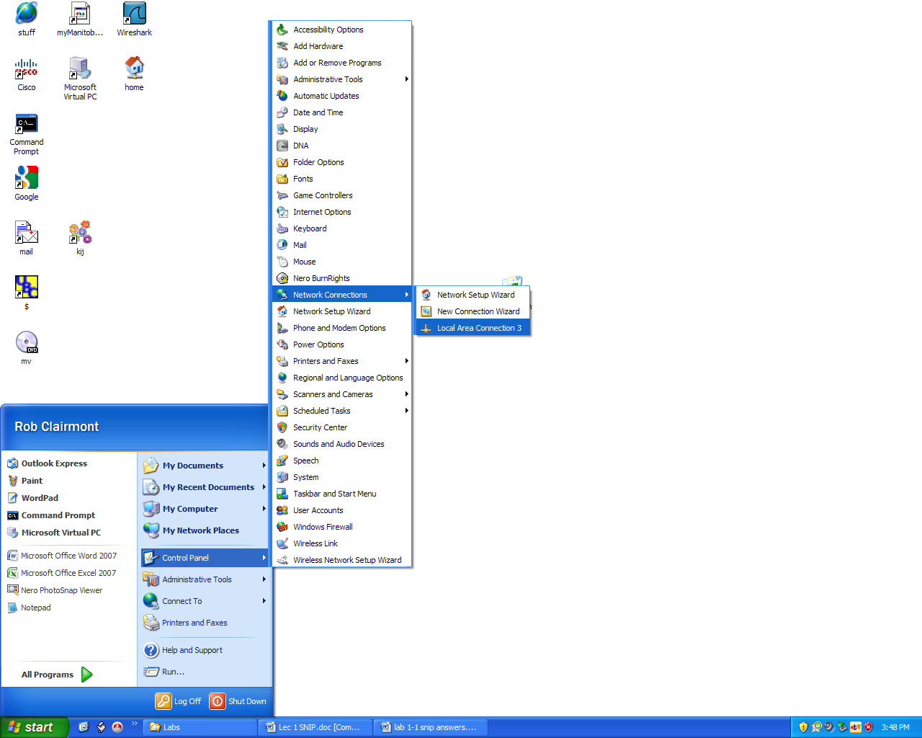

Fig. 2 Accessing the properties page of the network card

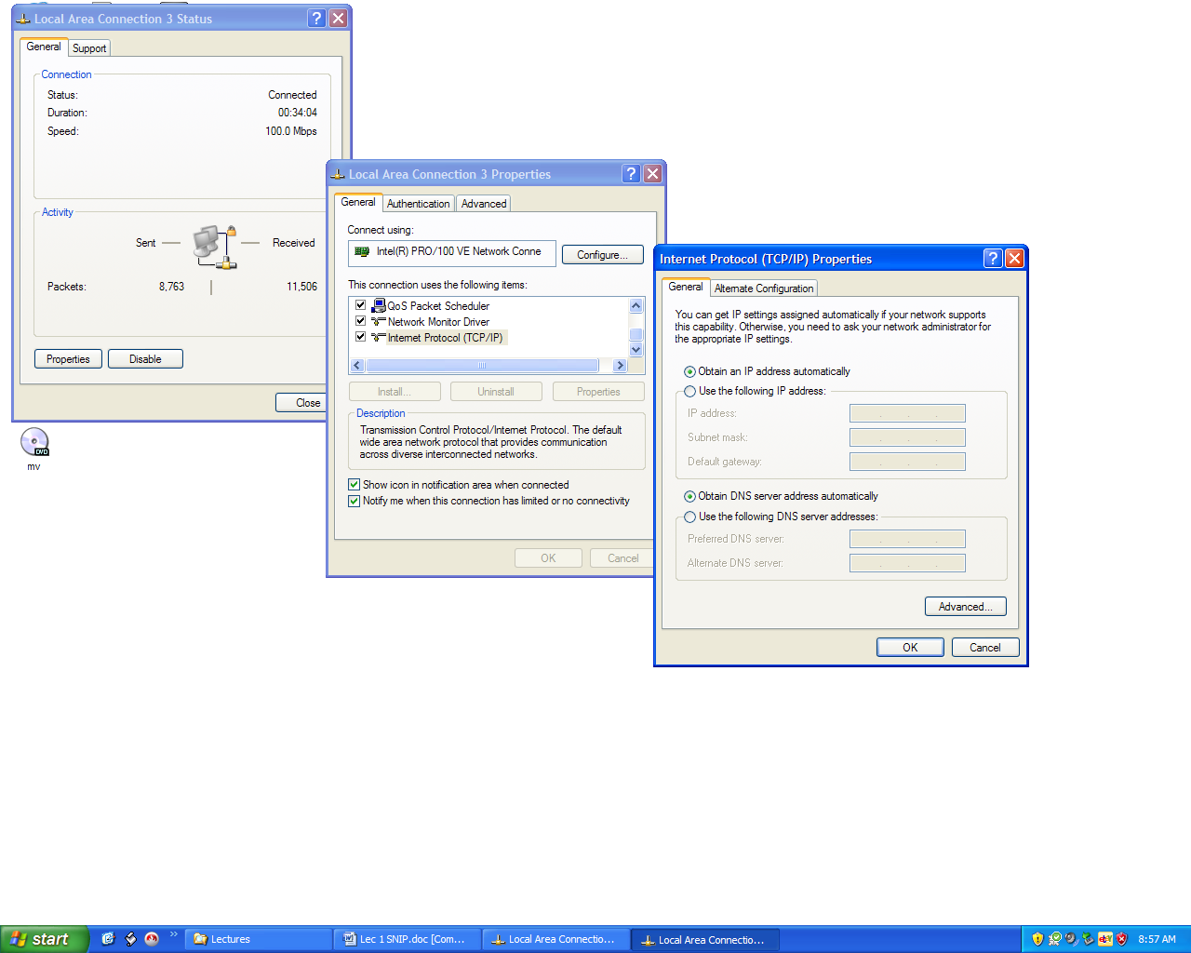

Fig. 3 Configuring a network card to obtain a DHCP address

Figure 3 shows how you go about configuring a host to obtain a DHCP address.

The host must be able to connect to a Dynamic Host Configuration Protocol (DHCP) server. The DHCP server keeps track of what IP addresses have been issued so it does not issue the same IP address to more than 1 client computer.

The DHCP server can be configured to send the client the IP address of the DNS server and the Gateway.

**DNS server** – The Domain Name Service server translates domain and host names into IP addresses. When you type [**http://www.rrc.ca**](http://www.rrc.ca) into the URL of the browser, it must be translated into the IP address of the WEB server before the browser can find the WEB server.

**Gateway** – a gateway is a router that can take packets off one network and place them on another network. Without a gateway, hosts would not be able to send packets to the internet. In figure 1, the routers are the gateways.

**Static IP address configuration** - Some hosts such as network printers, WEB servers, DNS servers, WINS servers, gateways, etc. should not have their IP addresses change at any time. These hosts must be configured with a static IP address. See figure 4.

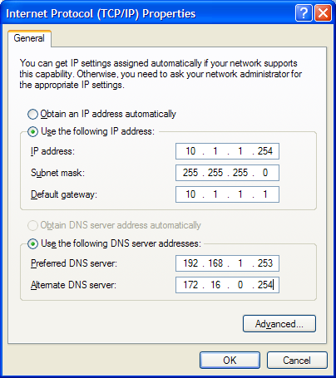

Fig. 4 Configuring a static IP address on a host

This is the same screen as in figure 3 except the option to “Use the following IP address:” has been selected.

**Subnet Mask** - The subnet mask indicates how many bits to use as the network portion of the address. By default, the subnet mask for a class A license is

255.0.0.0. If you take any IP address in a class A license, you can find what network that host is on by **AND**ing the binary IP address to the binary subnet mask.

For instance, to find out what network 10.225.160.34 is on, convert the IP address to binary and logically AND it with the binary equivalent of the subnet mask.

The rules for logical ANDing are:

A B AND

0 0 0

0 1 0

1 0 0 What this means is when you compare two bits, if one of them is

1 1 1 a zero the result of ANDing is a zero. Both bits must be a “1” to get

a “1”

10.225.160.34 = 0000 1010.1110 0001.1010 0000.0010 0010

255.0.0.0 = **1111 1111**.0000 0000.0000 0000.0000 0000

Result of ANDing = 0000 1010.0000 0000.0000 0000.0000 0000

**The network is 10.0.0.0**

An administrator can **subnet** a network to make multiple networks from 1 license. Each subnet would contain fewer hosts than the original classful license.

In the last example, if we use a subnet mask of 255.255.255.0 the network that 10.225.160.34 is found on, is:

10.225.160.34 = 0000 1010.1110 0001.1010 0000.0010 0010

255.255.255.0 = **1111 1111.1111 1111.1111 1111**.0000 0000

Result of ANDing = 0000 1010.1110 0001.1010 0000.0000 0000

**The network is 10.225.160.0**

If the classful license is used for a class A network, there would be a possible 16,777,214 hosts on that network. Too many hosts on one network results in congestion. The smart thing to do, is to subnet the original classful license into smaller networks by changing the subnet mask. With a subnet mask of 255.255.255.0 for a class A license, we are left with 8 bits for the host portion. This results in 28 – 2 = 254 hosts per network. This is a more manageable number.

Another way of looking at what a subnet mask does, is think of it as the mechanism that zeros-out the host portion leaving only the network portion. In the last example, “34” is the host portion. You can see that when the subnet mask is ANDed with the IP address, the result is the host portion has been changed to zeros.

Two hosts cannot talk to each other if they are not on the same network. They would need a router placed between them to be able to talk to each other when they are on different networks.

When a host tries to send a packet to another host that is on a different network, the host sends the packet to the gateway address, which is the router. The router then checks its routing table to see if the destination network is in the routing table. If it is, the router can forward the packet on to the next router which then tries to deliver the packet. If the destination network is not in the router’s routing table, the router sends the host an error message saying the packet cannot be delivered

**Hexadecimal numbers**

Hexadecimal numbers use all the digits 0 to 9 and then A,B,C,D,E,F for the numbers 10,11,12,13,14, and 15 respectively. Hex numbers are used to express MAC addresses. Each hex number consists of 4 bits. C = 1100, E=1110, etc.

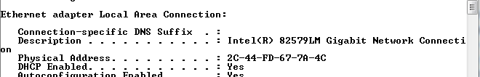

Fig. 5 The MAC address or physical address is expressed in hexadecimal format